Dear Indianapolis Agent of Change,
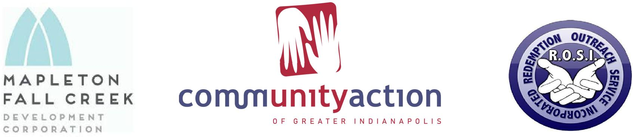
Redemption Outreach Services, Inc. (R.O.S.I) in partnership with Community Action of Greater Indianapolis (CAGI) and Mapleton Fall Creek Development Corporation (MFCDC) is hosting our annual event “The 2020 Art in the Park – Embracing Financial Wellness for community enrichment.” This year it will be held at Garfield Park in Indianapolis, Indiana on August 8, 2020. We are reaching out to all of our community
partners to offer them the opportunity to provide services, disseminate information, and gain visibility and reach to community stakeholders. We hope that you or your organization will come out to participate and enjoy performances from nationally recognized recording artists, local performing artists, and many other local talents. We are anticipating a huge turnout and want to invite your business to be part of the action!!!
By becoming a sponsor to “The 2020 Art in the Park- Embracing Financial Wellness for community enrichment” event, your business and support will help to further the following missions:
R.O.S.I - “Empowering others to reach their full potential by infusing knowledge-based training, success fundamentals and support. Strengthen an individual, economically and socially to display selfsustainability and accountability to spite past conditions, for the betterment of our society as a whole. Where one’s past does not dictate their future and hard work and commitment to success is rewarded in prosperity.”
CAGI – “To empower those we serve to become self-sufficient and self-reliant.”
MFCDC – “Connecting neighborhood partners to help, serve, revitalize, stimulate, and invest resources to rebuild an affordable, safe, and vital community.”
Every day we work with the goal to help families and individuals become financially self-sufficient and self-reliant, to promote and support homeownership, to work towards success through personal development and employment, and to erase stigmas and barriers that many youth struggle with through foster care into adulthood. Achieving these goals and accomplishing our missions will help to build stronger families, better communities, and more self-reliant citizens in Indianapolis. You and your business can help bring a positive change in someone’s life.
Attached is information on the sponsorship levels we have available for our event. We hope that you will find a level that suits your marketing budget and will contribute a charitable contribution to help us have an amazing and fun event this year! Your sponsorship could be tax deductible due to our 501c3 status as a nonprofit/charitable organization in good standing with the IRS; however, you should consult your own tax advisor. If you have any questions regarding this sponsorship, we invite you to reach out to any of the contacts listed below. To place visibility on additional information on any of our missions and programs in action, please visit our websites or look us up on Facebook.
With sincere gratitude from all of us at Redemption Outreach Services, Inc., Community Action of Greater Indianapolis, Inc., Mapleton Fall Creek Development Corporation, and our partners, we thank you for any and all consideration. We look forward to seeing you at this year’s Art in the Park- Embracing Financial Wellness for community enrichment at Garfield Park and together let’s make a difference!
Truest Regards,
Demetrice L. Bruno Terrence White Courtney Goodwyn
R.O.S.I Founder/CEO Executive Director, CAGI Director, MFCDC
Redemption.outreach.1@gmail.com twhite@cagi-in.org Courtney@mfcdc.org

